**Install MySQL on Windows 10**

By[Mel Khamlichi](https://www.osradar.com/author/mohamed/)

January 25, 2018

[0](https://www.osradar.com/install-mysql-windows-10/#respond)

3755

Share

[Facebook](https://www.facebook.com/sharer.php?u=https%3A%2F%2Fwww.osradar.com%2Finstall-mysql-windows-10%2F)

[Twitter](https://twitter.com/intent/tweet?text=Install+MySQL+on+Windows+10&url=https%3A%2F%2Fwww.osradar.com%2Finstall-mysql-windows-10%2F&via=OSRadar)

[Pinterest](https://pinterest.com/pin/create/button/?url=https://www.osradar.com/install-mysql-windows-10/&media=https://www.osradar.com/wp-content/uploads/2018/01/1200px-MySQL.svg_.png&description=Install+MySQL+on+Windows+10)

[WhatsApp](whatsapp://send?text=Install+MySQL+on+Windows+10%20%0A%0A%20https:/www.osradar.com/install-mysql-windows-10/)



Must read

[**Desktop**](https://www.osradar.com/category/desktop/)

[5 things to do after installing Ubuntu 20.04](https://www.osradar.com/5-things-to-do-after-installing-ubuntu-20-04/)

[**angeloma**](https://www.osradar.com/author/angelomarquez/)-April 25, 2020 [**0**](https://www.osradar.com/5-things-to-do-after-installing-ubuntu-20-04/#respond)

The new version of Ubuntu has been recently published. As we already know it is an LTS version which implies that it will have...

[Read more](https://www.osradar.com/5-things-to-do-after-installing-ubuntu-20-04/)

[**Desktop**](https://www.osradar.com/category/desktop/)

[Ubuntu 20.04 LTS available](https://www.osradar.com/ubuntu-20-04-lts-available/)

[**angeloma**](https://www.osradar.com/author/angelomarquez/)-April 24, 2020 [**0**](https://www.osradar.com/ubuntu-20-04-lts-available/#respond)

The Linux world is shaking every 6 months thanks to Ubuntu and its new stable versions, but this time a very special...

[Read more](https://www.osradar.com/ubuntu-20-04-lts-available/)

[**Linux**](https://www.osradar.com/category/linux/)

[How to install RStudio on Ubuntu 18.04 / Linux Mint 19.x?](https://www.osradar.com/how-to-install-rstudio-ubuntu-18-04-linux-mint-19-x/)

[**angeloma**](https://www.osradar.com/author/angelomarquez/)-April 23, 2020 [**0**](https://www.osradar.com/how-to-install-rstudio-ubuntu-18-04-linux-mint-19-x/#respond)

No matter how complete and robust a programming language is, the programmer will always need a tool to write the code. These programs have...

[Read more](https://www.osradar.com/how-to-install-rstudio-ubuntu-18-04-linux-mint-19-x/)

[**Applications**](https://www.osradar.com/category/applications/)

[Snowflake an SSH client for Linux](https://www.osradar.com/snowflake-an-ssh-client-for-linux/)

[**angeloma**](https://www.osradar.com/author/angelomarquez/)-April 22, 2020 [**0**](https://www.osradar.com/snowflake-an-ssh-client-for-linux/#respond)

Linux system administrators on servers have a big job behind them. Thanks to them, many of the services or tasks that an...

[Read more](https://www.osradar.com/snowflake-an-ssh-client-for-linux/)

[](https://www.osradar.com/author/mohamed/)

[Mel Khamlichi](https://www.osradar.com/author/mohamed/)

Webmaster and technical Director at Osradar.com Linux/Unix Guru Technology and hardware addicted Location : Amsterdam Netherlands

MySQL is an open source relational database management system (RDBMS). It has the most comprehensive set of advanced features and management tools which ensures the highest level of scalability, security, and reliability with no downtime. This guide will help you to install MySQL on Windows 10 with step by step walkthrough. There are different ways available to install MySQL in Windows 10, but we will follow the process using MySQL Installer. So, let’s get started:

**Downloading MySQL:**

* **Step 1:** Determine your Operating System whether it’s x86 or x64. To do that, press **Winsows+X** and click **System.** It will take you to the **About** page and you will see the system configuration.
* **Step 2:** Go to the MySQL [download](https://dev.mysql.com/downloads/windows/) page and click [MySQL Installer](https://dev.mysql.com/downloads/installer/).

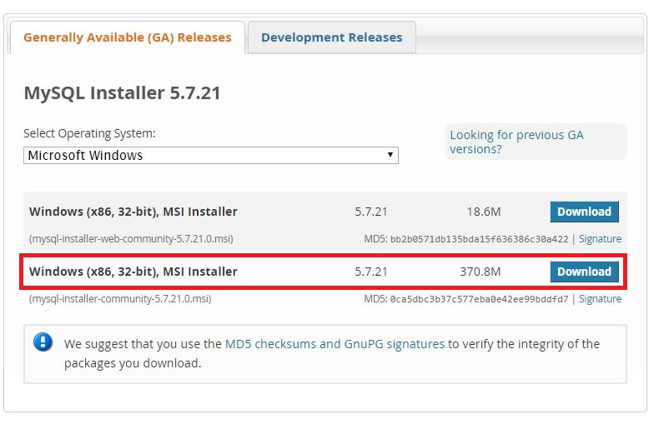

* **Step 3:** Scroll down the page and download the second installer file. You can skip the login/signup by clicking “No thanks, just start my download.”

**Install MySQL on Windows 10:**

* After downloading the file, locate it on your computer and double-click to install. It will popup **User License Agreement** screen, accept the agreement and the install wizard will appear.
* Now, select the **Custom** option and click **Next.**

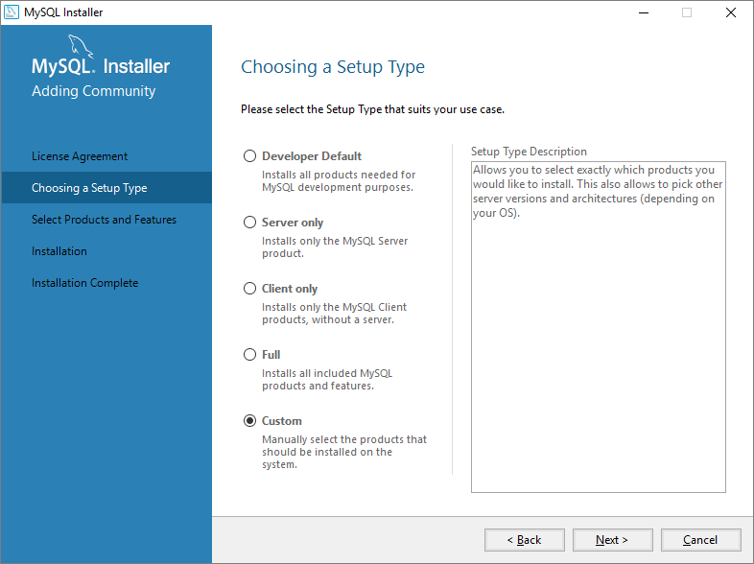

* Next screen will ask you to choose the products to install.
  + Expand **MySQL Servers** and select MySQL Server 5.x.xx
  + Expand **Application,** click **MySQL Workbench** and select **workbench.**
  + Click **Documentation** and select **MySQL Documentation.**
  + Click **Sample** and select **Examples 5.x.xx**
* Now click **Next** and the installation process will start. It will take a while and when the process finishes, click **Next**.

**Configuring MySQL on your Computer:**

You will need to configure the MySQL for the first time and once to make it usable. A Configuration Window will pop up.

* Keep the **Configuration Type** as Development Machine and set the TCP/IP port as 3306. Now, check the **Show Advanced Options**and click **Next.**

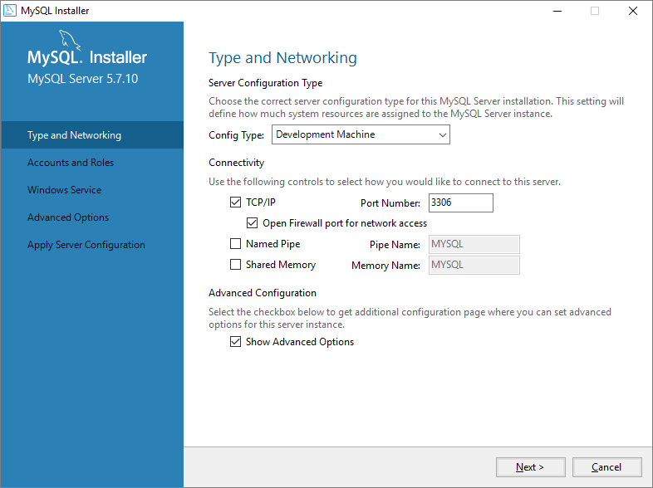

* Ignore the **user** tab and just put a strong password and click **Next**.

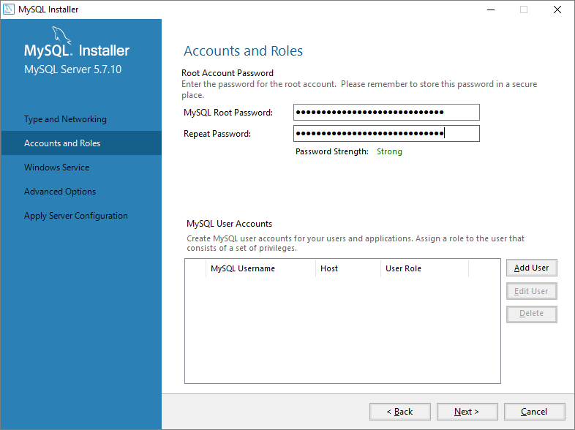

* Click Next. **Install** MySQL as a Windows Service. This is the easiest settings to start, stop, restart MySQL and allow Windows to start MySQL when Windows starts.

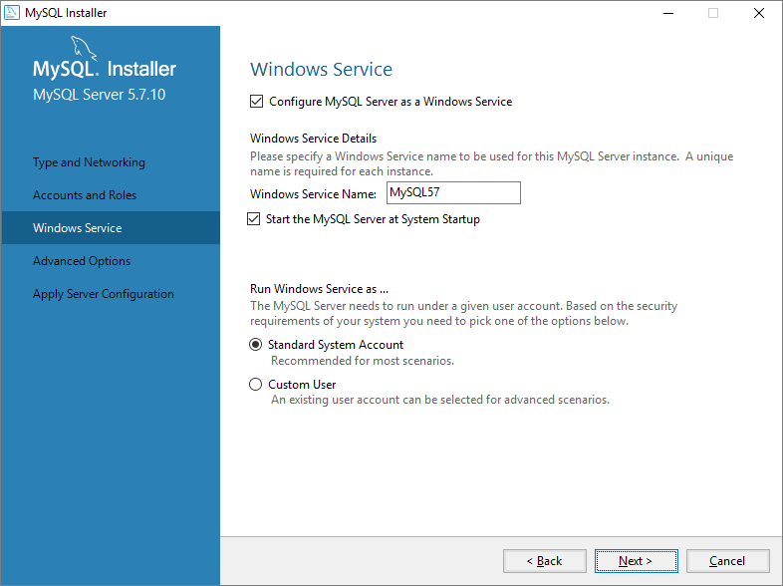

* Leave the advanced settings as it is and click **Next** to Execute. It will take you to the **Product Configuration** window.

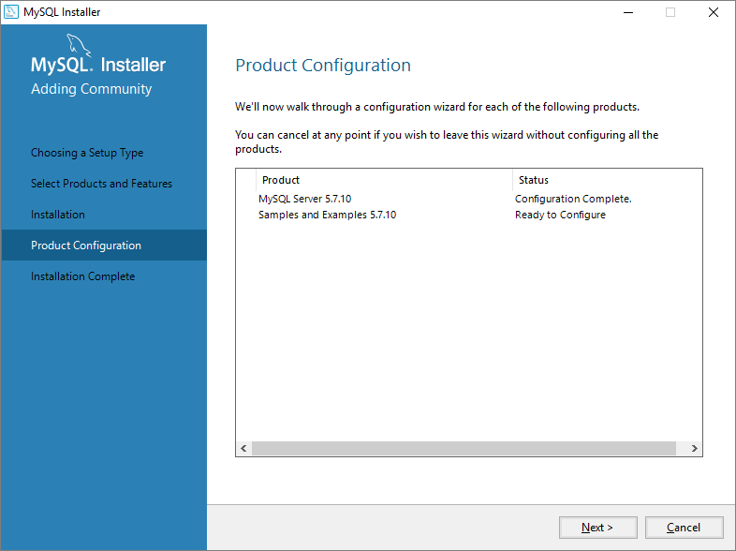

* Click Next. In the screen, click **Check** option, that enables the **Next** button.

Now, you can follow the next steps with default settings. Click Execute. This process will run all the necessary scripts to configure sample. If it is successful, click Finish.

Click **Next**. Leave Start MySQL Workbench after Setup checked. Click **Finish**. Workbench will start by itself in a few seconds

If you are at this point, you have completed the installation of MySQL on your Windows 10 Computer. Now, as the MySQL database has been installed, it’s already running on your computer. All you will need is to connect to MySQL database. You can use MySQL Workbench as a client to connect to MySQL. When Workbench starts, a connection to the local database will automatically be established.

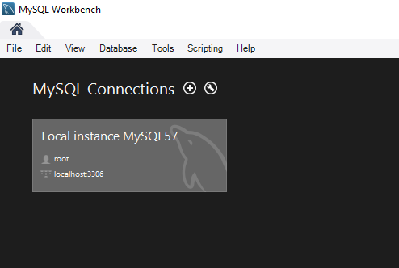

Double-click on Local instance MySQL57 connection and type the root password you used back then to install MySQL to gain access to the server.

Congratulations! You have successfully installed MySQL on Windows 10 Computer.

If anything goes wrong, check the error log. You can search the errors on Google or follow above steps to install MySQL on Windows 10 again!

* Tags
* [Install MySQL in Windows 10](https://www.osradar.com/tag/install-mysql-in-windows-10/)

Share

[Facebook](https://www.facebook.com/sharer.php?u=https%3A%2F%2Fwww.osradar.com%2Finstall-mysql-windows-10%2F)

[Twitter](https://twitter.com/intent/tweet?text=Install+MySQL+on+Windows+10&url=https%3A%2F%2Fwww.osradar.com%2Finstall-mysql-windows-10%2F&via=OSRadar)

[Pinterest](https://pinterest.com/pin/create/button/?url=https://www.osradar.com/install-mysql-windows-10/&media=https://www.osradar.com/wp-content/uploads/2018/01/1200px-MySQL.svg_.png&description=Install+MySQL+on+Windows+10)

[WhatsApp](whatsapp://send?text=Install+MySQL+on+Windows+10%20%0A%0A%20https:/www.osradar.com/install-mysql-windows-10/)

Previous article[Automated Tool from Linux Lite Devs – Check for Meltdown and Spectre](https://www.osradar.com/automated-tool-from-linux-lite-devs-check-for-meltdown-and-spectre/)

Next article[How to Create Self-signed Certificate on Windows](https://www.osradar.com/create-self-signed-certificate-windows/)